

NAME : V . RAJ KUMAR
BATCH NO: 140
EMAIL ID : vodnalar26@gmail.com

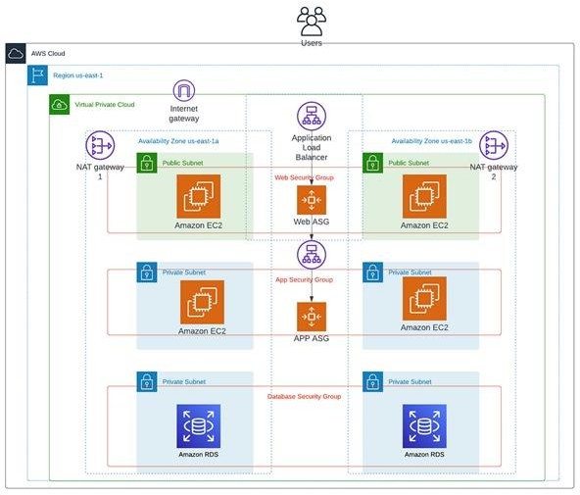

3-TIER ARCHITECTURE

INTRODUCTION TO 3-TIER ARCHITECTURE
Three-tier architecture is a well-established software application architecture that organizes applications into three logical and physical computing tiers: the presentation tier, or user interface; the application tier, where data is processed; and the data tier, where application data is stored and managed.
The chief benefit of three-tier architecture is that because each tier runs on its own infrastructure, each tier can be developed simultaneously by a separate development team. And can be updated or scaled as needed without impacting the other tiers.
For decades three-tier architecture was the prevailing architecture for client-server applications. Today, most three-tier applications are targets for modernization that uses cloud-native technologies such as containers and microservices and for migration to the cloud.

PRESENTATION TIER:
The presentation tier is the user interface and communication layer of the application, where the end user interacts with the application. Its main purpose is to display information to and collect information from the user. This top-level tier can run on a web browser, as desktop application, or a graphical user interface (GUI), for example. Web presentation tiers are developed by using HTML, CSS, and JavaScript. Desktop applications can be written in various languages depending on the platform.
APPLICATION TIER:
The application tier, also known as the logic tier or middle tier, is the heart of the application. In this tier, information that is collected in the presentation tier is processed - sometimes against other information in the data tier - using business logic, a specific set of business rules. The application tier can also add, delete, or modify data in the data tier.
The application tier is typically developed by using Python, Java, Perl, PHP or Ruby, and communicates with the data tier by using API calls.
DATA TIER:
The data tier, sometimes called database tier, data access tier or back-end, is where the information that is processed by the application is stored and managed. This can be a relational database management system such as PostgreSQL, MySQL, MariaDB, Oracle, Db2, Informix or Microsoft SQL Server, or in a NoSQL Database server such as Cassandra, CouchDB, or MangoDB.
In a three-tier application, all communication goes through the application tier. The presentation tier and the data tier cannot communicate directly with one another.

AWS INFRASTRUCTURE SETUP PROCESS:-
NETWORKING SETUP:
Step1: Create a VPC with a defined CIDR block (e.g., 10.0.0.0/16).
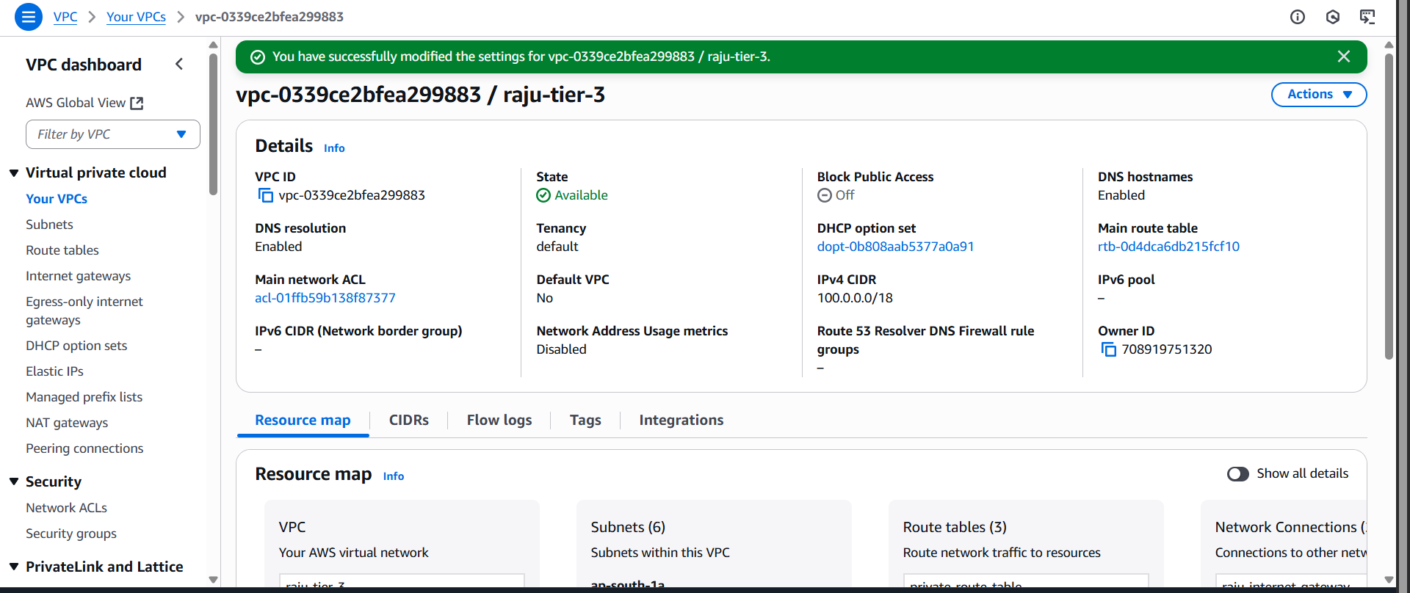

Step2: Add subnets
Public 2 subnets (for internet-facing resources).
Private 4 subnets (for databases, internal services)
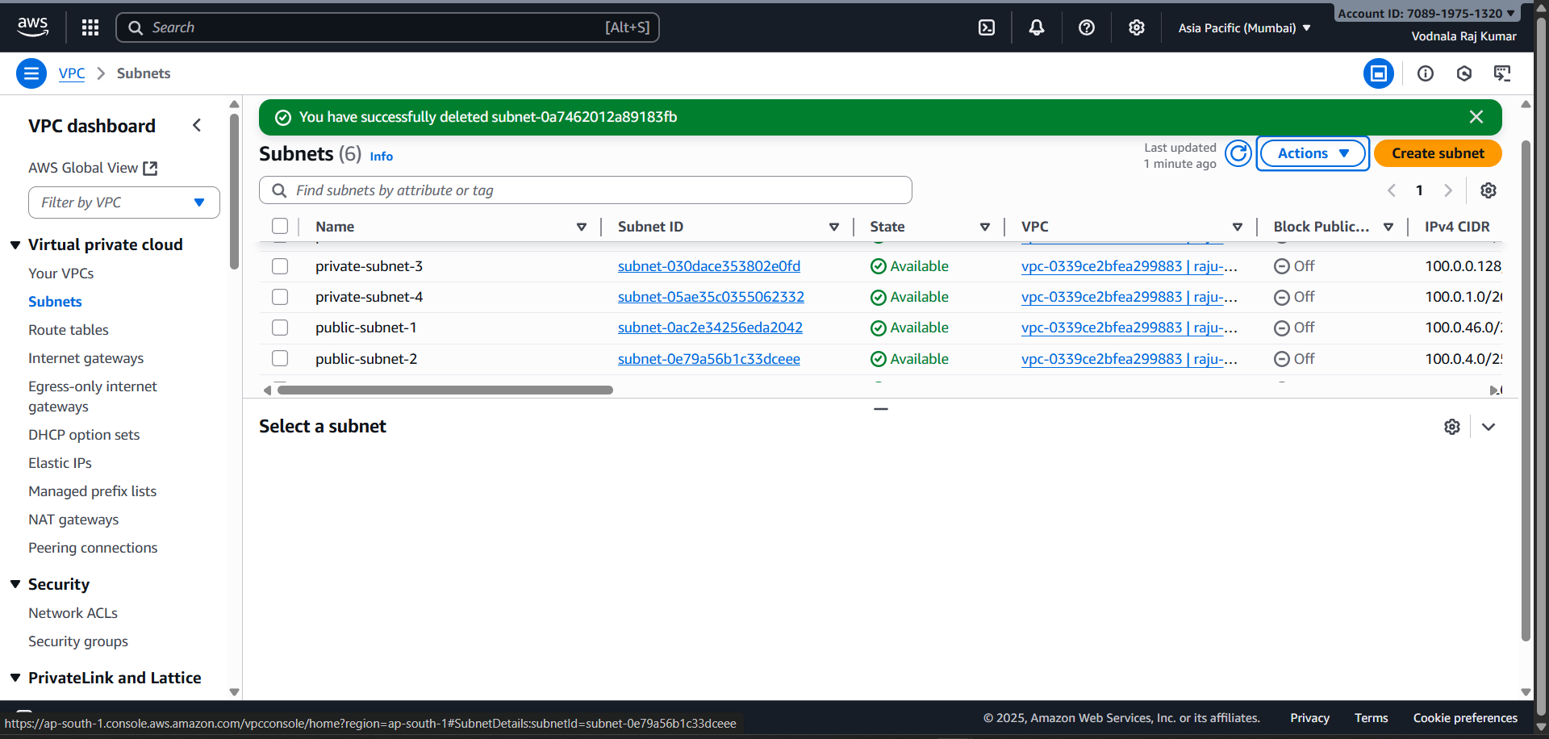

Step3: Configure Internet Gateway (for public access).
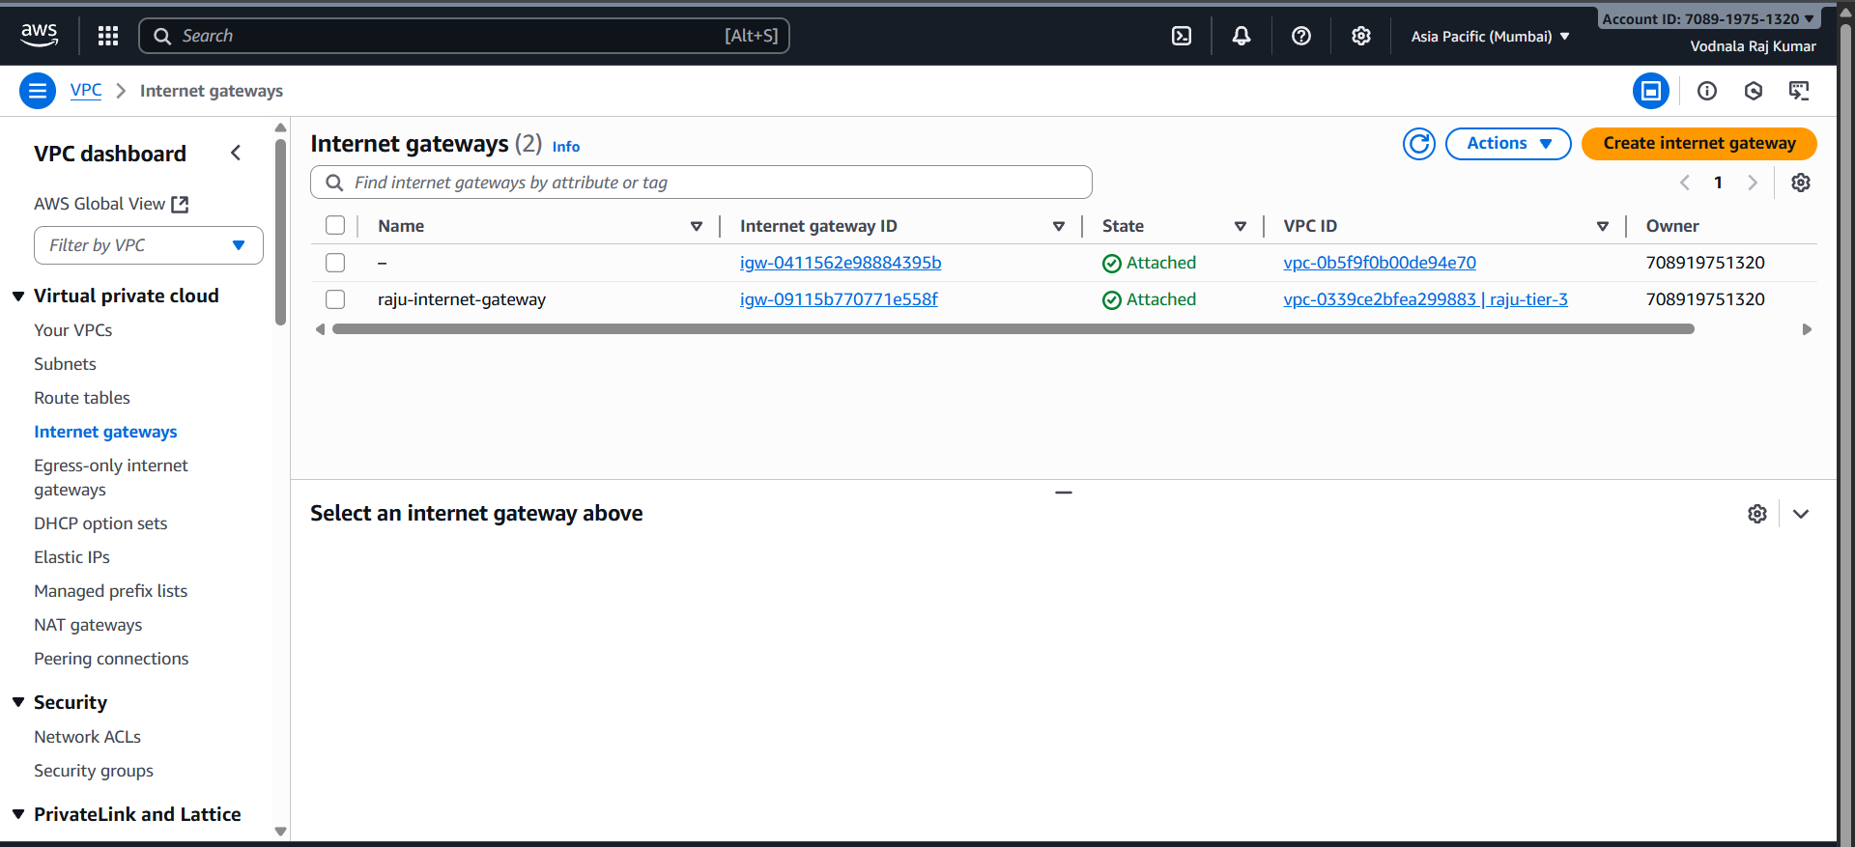
Step4: Set up NAT Gateways in public subnets to enable instances in private subnets to access the internet for updates and external services without being directly accessible from the internet.
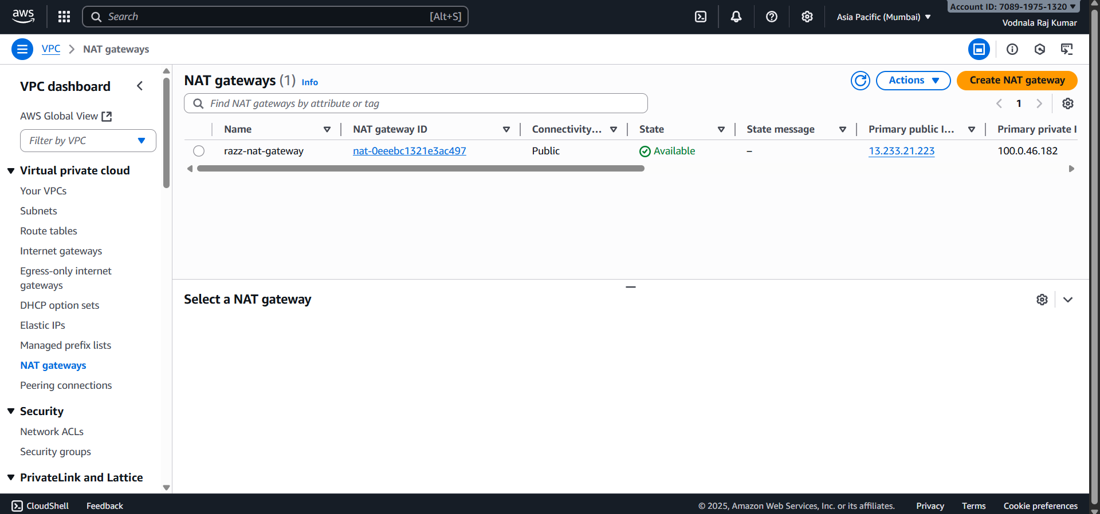

Step 5: Configure route tables to direct traffic appropriately, especially for public subnets to reach the internet via the Internet Gateway.
- Associate or connect Internet Gateway with the public subnets.
- Associate or connect NAT Gateway with the private subnets - 1 and 2
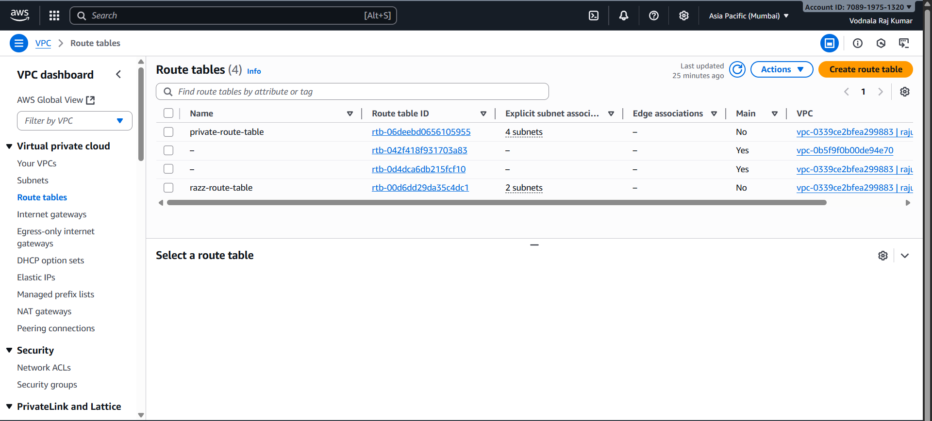
Step 6: Define Security Groups to act as virtual firewalls for your EC2 instances and other resources. Configure inbound and outbound rules to control traffic flow, ensuring only necessary ports (e.g., SSH, HTTP, database ports) are open to authorized sources.
- Create a security group for all the 4 instances.Create a security group for the RDS.
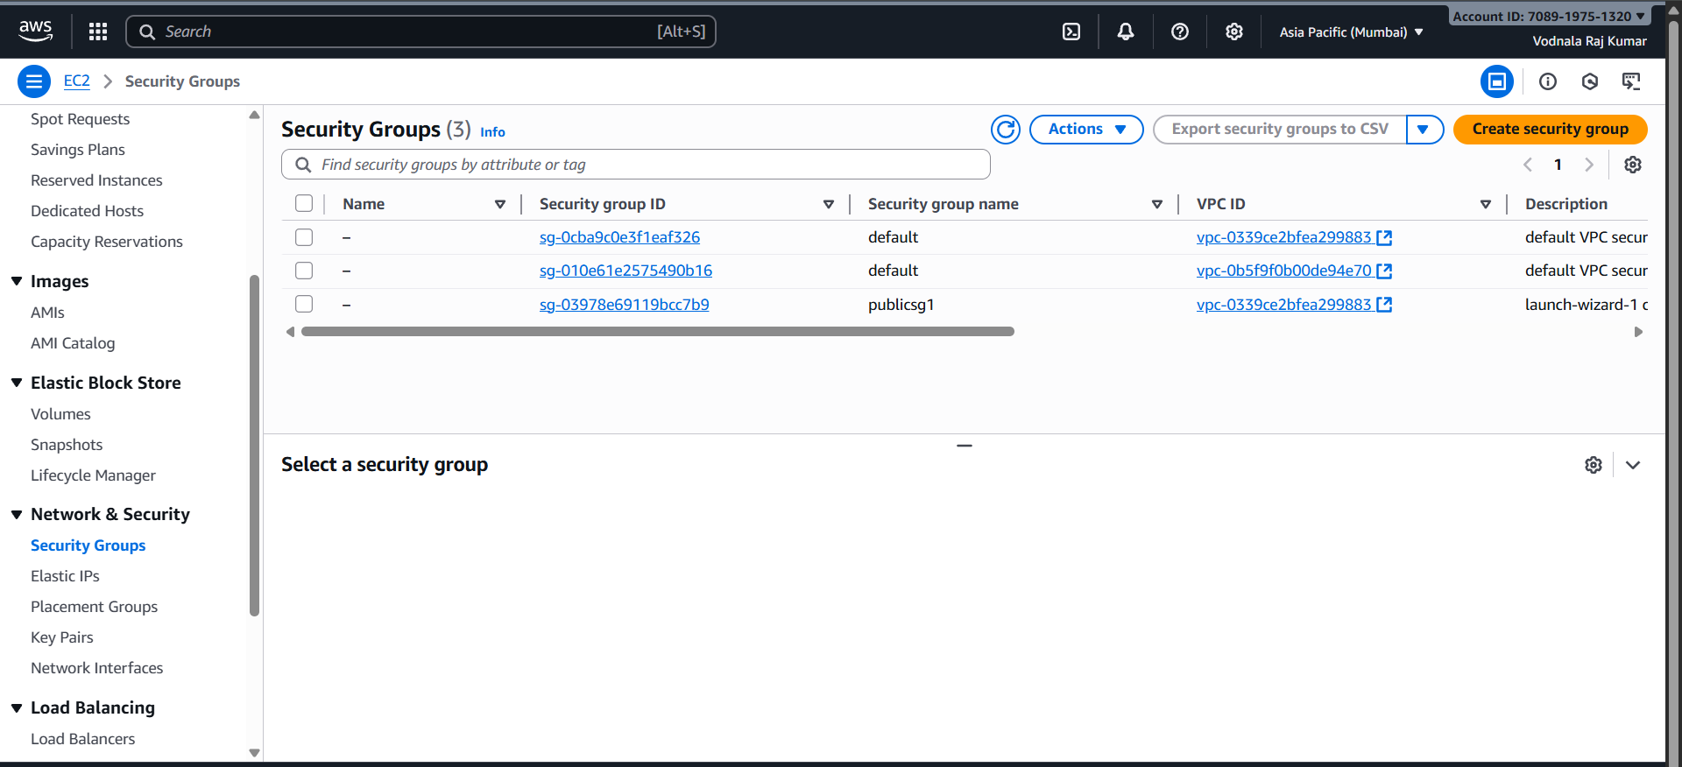

WEB TIER SETUP:
Step 7: Launch EC2 Instances: Launch Amazon EC2 instances (your virtual servers) into the public subnets. These instances will run web servers like Nginx or Apache.Auto Scaling Group: Create an Auto Scaling Group to automatically adjust the number of EC2 instances based on demand. This ensures your application can handle traffic spikes and remains highly available.
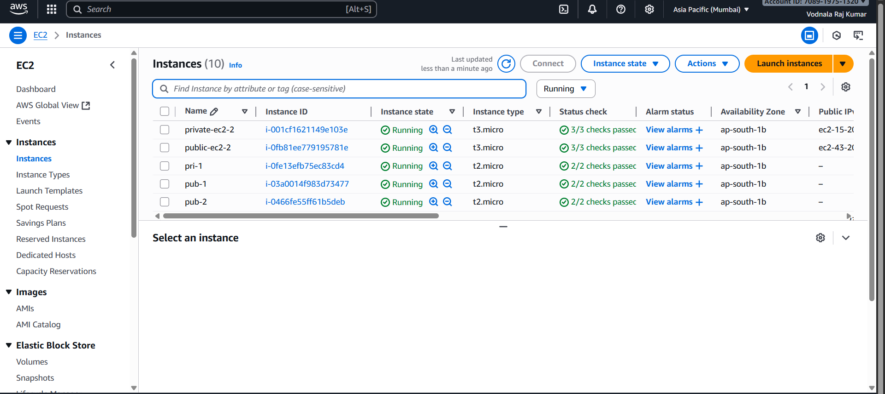
Step 8: Auto Scaling Group: Create an Auto Scaling Group to automatically adjust the number of EC2 instances based on demand. This ensures your application can handle traffic spikes and remains highly available.
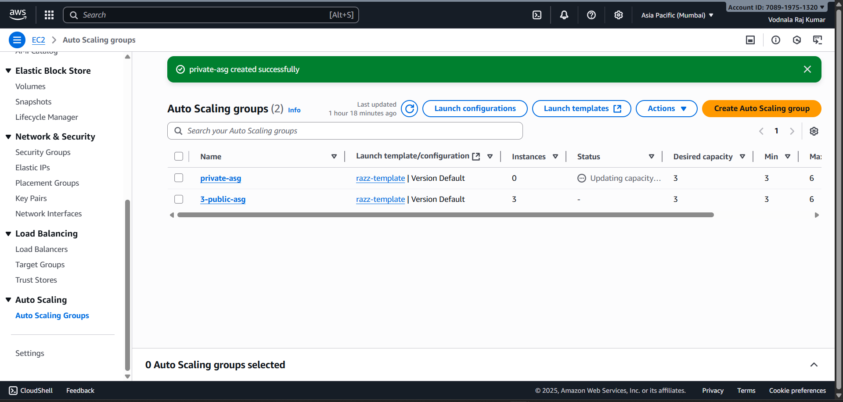

Step 9: Create target groups to register your EC2 instances, preparing them for load balancing.Create a target group for public instances and attach public instances while creating the target group.Create another group for the private instances and attach the private instances while creating the target group.
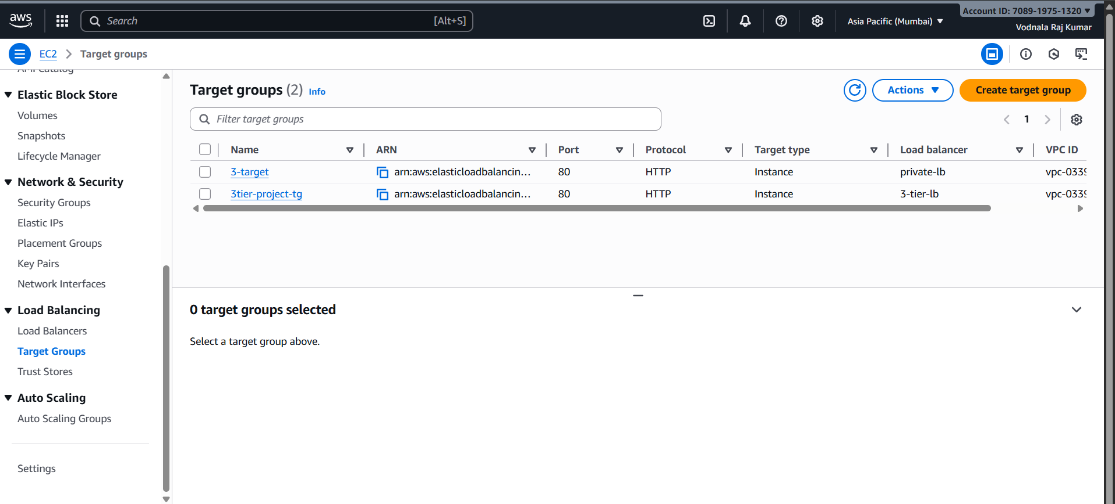

Step 10: : Define launch templates to standardize the configuration of your EC2 instances, including the operating system, instance type, and security settings.Create an AMI for duplication of the server and attach it to Launch Template while creating.
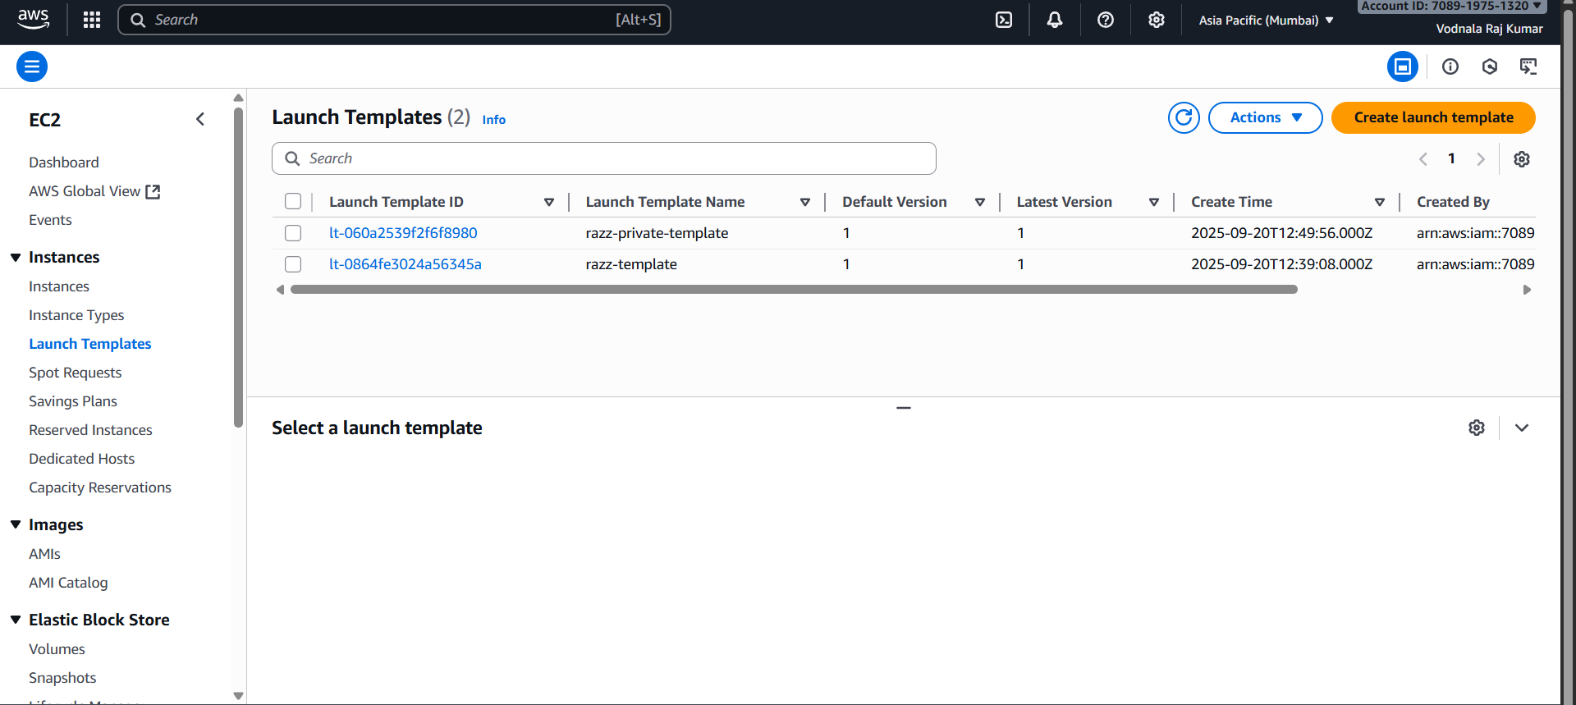

Step 12: create a AMI(Auto Machine Image).
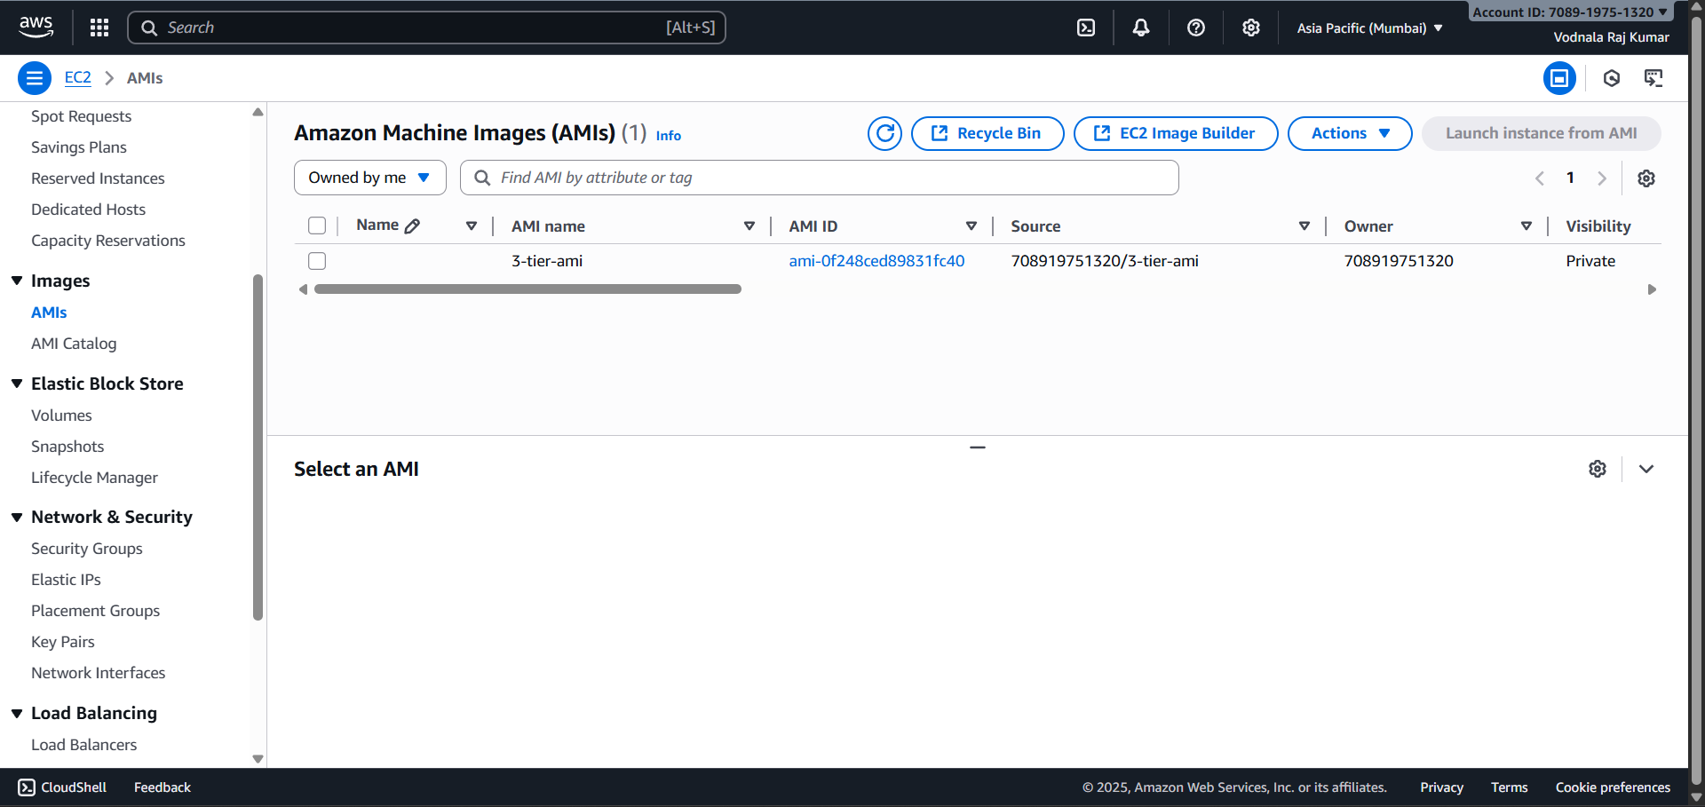

Step 13: Application Load Balancer (ALB): Place an ALB in front of the web tier. The ALB distributes incoming web traffic across the EC2 instances in the public subnets, ensuring no single instance is overloaded. It also performs health checks.
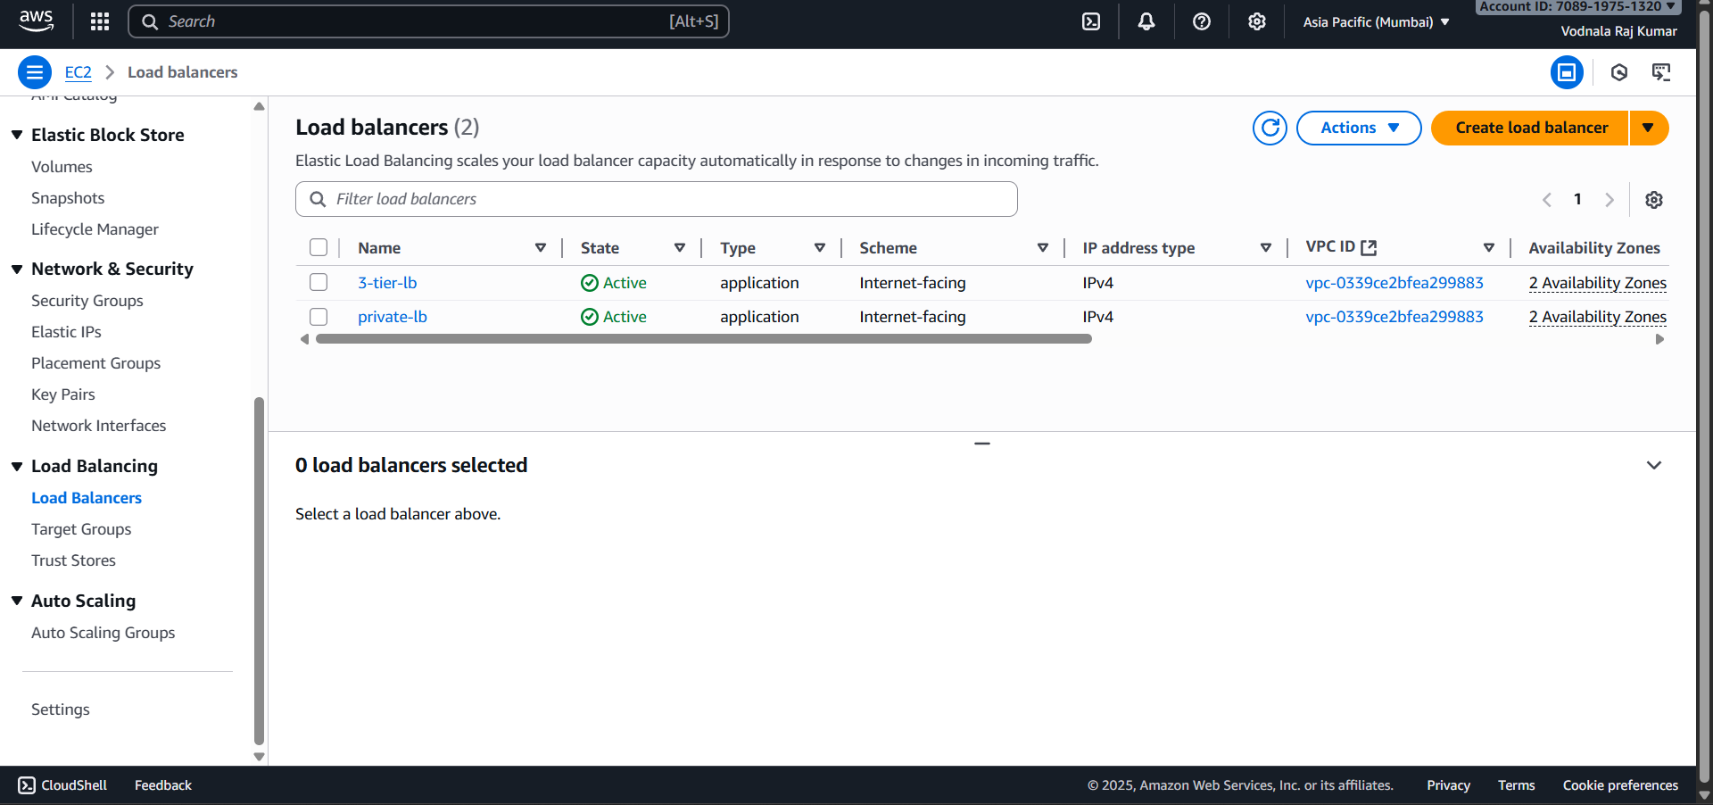

3.DATA TIER:
Step 14: Launch RDS Instance: Use Amazon RDS (Relational Database Service) to deploy a managed database instance (e.g., MySQL, PostgreSQL) in the private subnets. RDS handles database management tasks like patching, backups, and scaling.
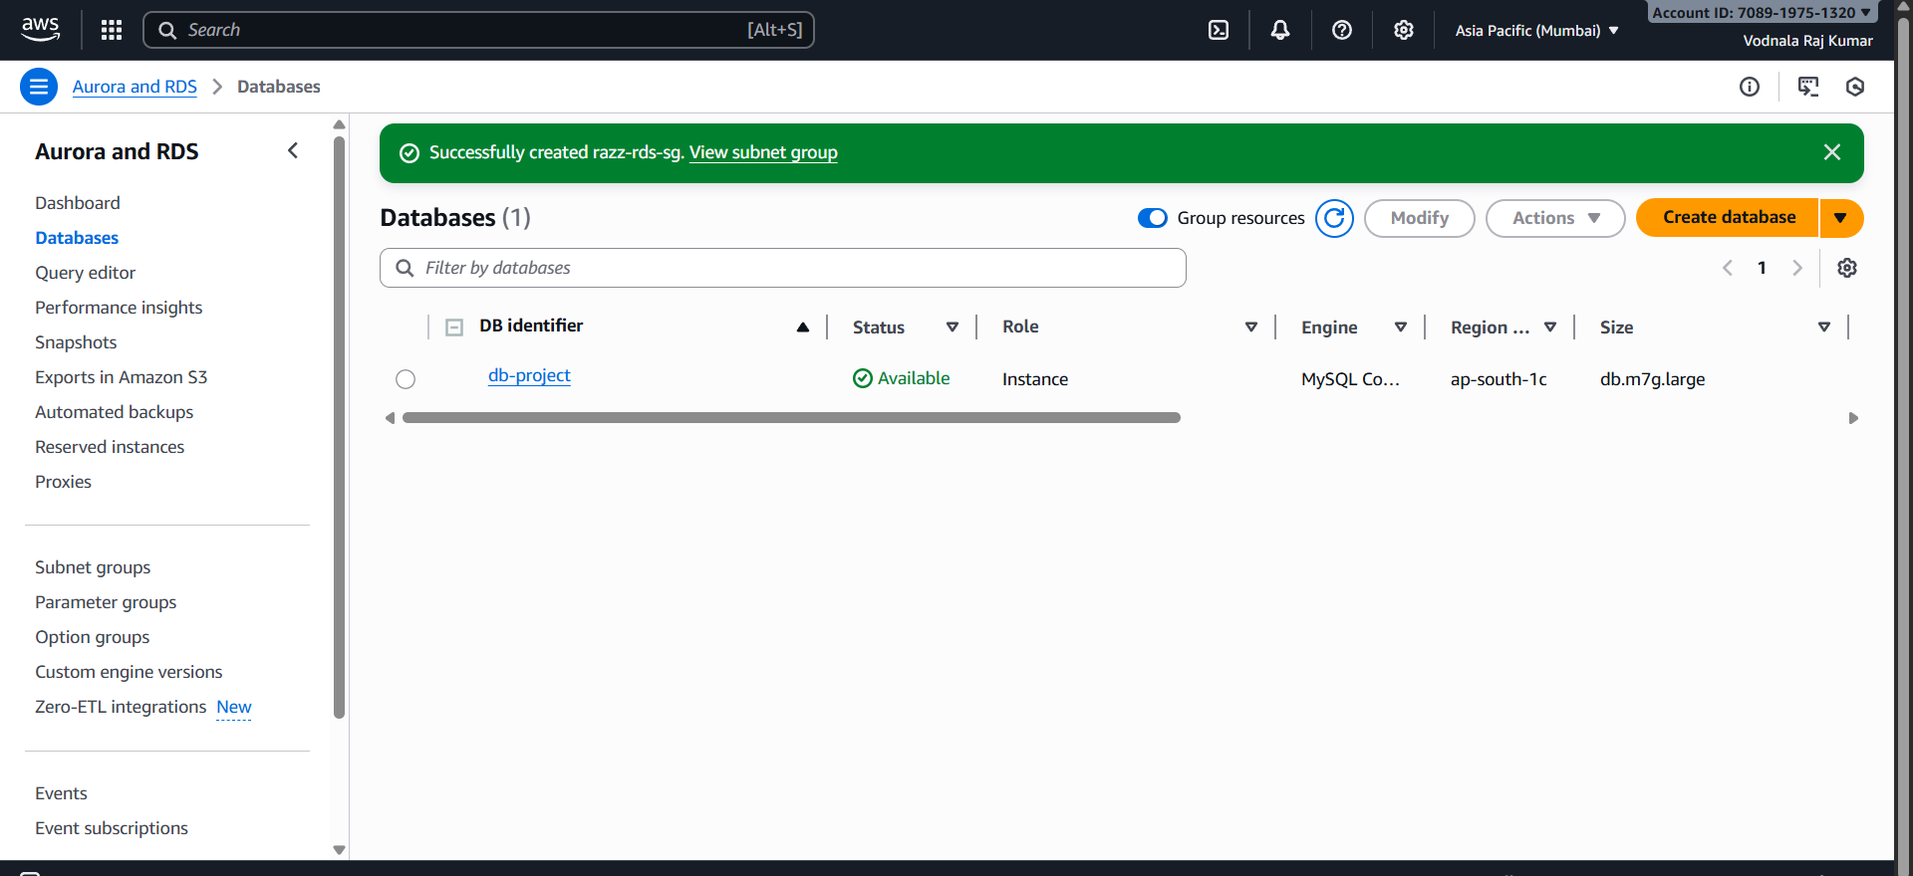
Step 15: Private Instance Database Connection & Setup: Connect to an instance in a private subnet via SSH, install the MySQL client, and then connect to the RDS instance. Create a database, a user table, and insert sample data.
- Steps to install MySQL in the Instance:
- sudo apt update
- sudo apt install mysql-server
- sudo systemctl start mysql.service
- Connect Database with the private instance: Command used : mysql -h Database DNS -u admin -p
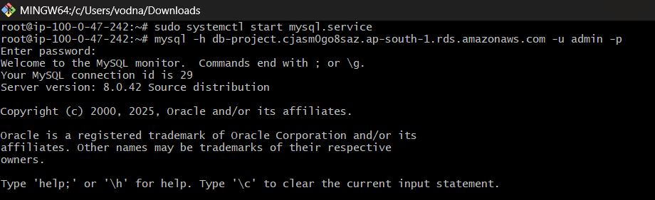

Step16: Generate the database using command called “create databases industry;”.
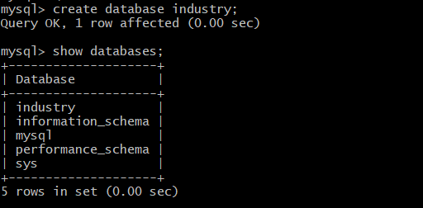
Step17: Create a table Labour by using command called ”CREATE TABLE;”.
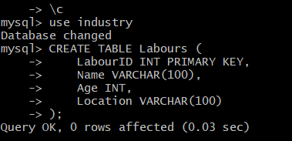
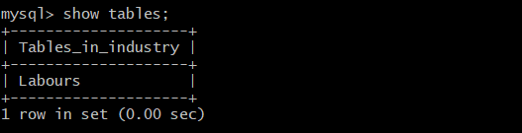

Step18:Insert data into it and use command called “SELECT*FROM in Labour;”.
Step 19: Public Instance Database Verification: Connect to instances in public subnets, repeat the MySQL client installation and RDS connection, and verify the data previously inserted into the database.This process outlines the fundamental steps to construct a resilient and scalable 3-tier architecture on AWS.
To verify the process, follow these steps:
Log out of the private instance.
​Install the MySQL server in the public instances.
​Connect to the database using the provided endpoints.
​Check if the data is visible by searching the databases and tables.
CONCLUSION OF THE PROJECT
The 3-tier architecture project has successfully demonstrated the benefits of separating an application into distinct tiers, enhancing scalability, security, and maintainability. By organizing the system into presentation, application, and data tiers, we've achieved a robust and efficient structure that can adapt to growing demands.
By adopting a 3-tier architecture, we've laid a solid foundation for a scalable, secure, and maintainable system that can support future growth and innovation.

